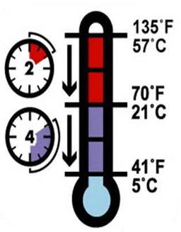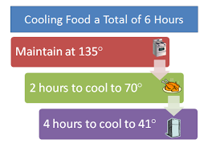

Potentially hazardous food requiring refrigeration after preparation shall be labeled with the date and time of preparation and rapidly cooled to an internal temperature of 41°F.

Potentially hazardous foods of large volume shall be rapidly cooled, utilizing such methods as limiting depth of food to 4 inches or less, agitation, quick chilling or water circulation external to the food container.

Cooked potentially hazardous food shall be cooled: From 135°F (60°C) to 70°F (21°C) within 2 hours; and from 70°F (21°C) to 41°F (4.5°C), or below, within 4 more hours (or within a total of 6 hours).